
RoboCupRescue - Robot League Team
RAPTOR (USA)
RoboCup2005
Rescue Robot League Competition
Osaka, Japan
July 13 – 19, 2005
www.robocup2005.org

Anton Chetchetka1, Steven Hughes2, Robin Glinton1, Mary Koes1, Michael Lewis2, Illah Nourbakhsh1, David Rosenberg1, Katia Sycara1, Jijun Wang²
1 Carnegie Mellon University
The Robotics Institute
5000 Forbes Ave.
Pittsburgh, PA USA 15213
usar-list@cs.cmu.edu
http://www.cs.cmu.edu/~softagents/project_grants_NSF.html

2 University of Pittsburgh
Computer Science Department
ml@sis.pitt.edu
http://www.pitt.edu/~cmlewis/
Abstract. A heterogeneous team of robots, agents, and people can collaborate to efficiently explore a disaster area and rescue as many victims as possible. RAPTOR (Robots-Agents-People Team: Operation Rescue) has a collection of 4 heterogeneous robots described in this paper along with our algorithms for autonomous victim identification and our efforts to design an efficient user interface to empower a single operator to utilize all the team resources.
Introduction
In the event of a natural or man made disaster in an urban environment, rescue workers must race against time to search buildings and rubble for victims. This task is currently undertaken primarily by humans and trained dogs. To minimize the risk of human life due to chemical or biological agents, fires, and additional collapses, robots could be used to explore the space, look for victims, and determine whether or not an area is safe for human rescue workers. As a step towards this goal, competitions like this RoboCup US Open Rescue Robot Competition allow researchers to test their robots, sensors, and software in a representative but controlled environment. The focus of RAPTOR (Robot-Agents-People Team: Operation Rescue) is to facilitate coordination between robots, agents, and people. We are particularly interested in the challenges that arise from the heterogeneity of the team members.
Our robot team members consist of two TurboPERs, Personal Exploration Rovers [7] that have been modified to go faster, a Pioneer P3-AT with laser range finder and mapping capabilities, and a retrofitted radio controlled Tarantula vehicle, capable of navigating extreme terrain and stairs. This paper describes our team strategy, the technical specifications of the robots, the user interface designed to allow a single operator to guide up to 4 robots simultaneously, and our algorithms for victim identification, localization, and mapping.
- Team Members and Their Contributions
- Katia Sycara Advisor
- Illah Nourbakhsh Advisor
- Michael Lewis Advisor
- Anton Chetchetka Mapping
- Robin Glinton Tarantula robot development
- Steven Hughes Human Factors
- Mary Koes Systems engineer
- Dave Rosenberg Software support
- Jijun Wang Simulator
- National Science Foundation Sponsor
- Intel Corporation Sponsor
- ActivMedia Sponsor
- Operator Station Set-up and Break-Down (10 minutes)
Our robots are designed to be transported as checked luggage on a commercial aircraft and so can easily be carried by the operator to the site for deployment. The operator will run a quick test to confirm that all robots are operational and then return to the operator station where we will us a table and chair for the main control station, a laptop computer. Although all control could be done from a single laptop, we plan on using multiple laptops or LCDs to facilitate operator awareness.
- Communications
We currently use 802.11b wireless Ethernet on a peer-to-peer network which does not require access points. Unfortunately, the processors on the TurboPERs are not capable of supporting 802.11a/g because the board does not support cardbus. We will make sure that communication remains on one channel/frequency in the 802.11b range but request this value prior to the competition to facilitate setup of the numerous robots.
Effective communication is one of the most important aspects of search and rescue robotics. In order to facilitate communication between different systems, allow dynamic team coordination on a large scale, and manage information in a principled way, we use the RETSINA [8] multi-agent system architecture (see figure 1). We transform physical robots into agents with the robot agent architecture (figure 1), an extension to the commonly used 3 Tier architecture. Agents can locate other agents by name using the Agent Name Service (ANS) or by capability using Matchmaker [9]. Interagent communication in RETSINA uses the KQML agent communication language. To improve efficiency, we have extended the RETSINA architecture with backchannels [1], direct simplex connections between agents, for low level information, i.e. video, state information, teleoperation imperatives (see figure 2). Although the autonomy limitations of the robots currently limits the extent to which we can draw on the power of the RETSINA architecture, we feel it is important to adopt this technology from the beginning in order to facilitate future work on teamwork and coordination.
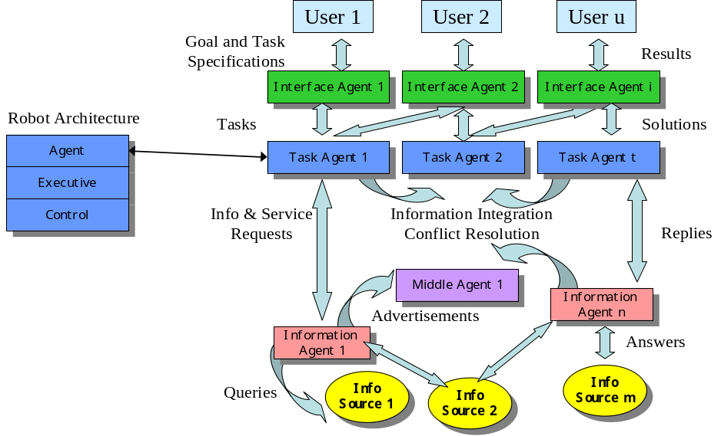
Fig. 1. The Robot Agent Architecture (left) enables robot integration in the RETSINA MAS functional architecture (right) by transforming physical robots into embodied task agents.

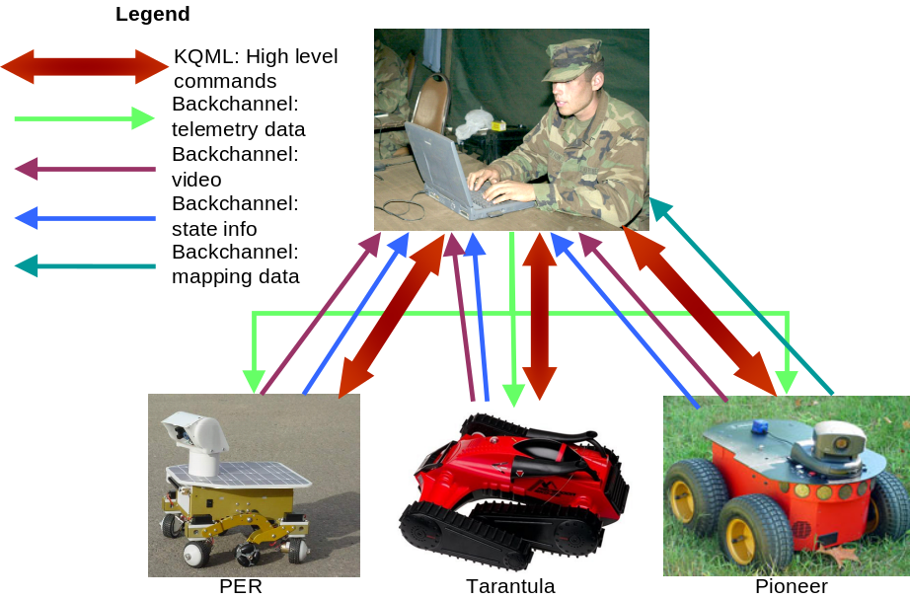
Fig. 2. RAPTOR communication architecture enables semantically meaningful communication for high level commands and efficient low level communication

Rescue Robot League
RAPTOR (USA)
MODIFY TABLE TO NOTE ALL FREQENCIES THAT APPLY TO YOUR TEAM
Frequency | Channel/Band | Power (mW)
2.4 GHz - 802.11b/g | Anything in  802.11b range | Orinoco card default
27 MHz:
may use with Tarantula
- Control Method and Human-Robot Interface
We have designed an interface agent that provides the operator the necessary feedback and enables the operator to control the robot as desired (figure 3). The interface agent has four separate components. The communication module handles all communication with the robot and other agents. The feedback module continuously polls the robot for information on the state of the environment (e.g. video) and the robot state (e.g. battery level) and displays this data to the user. One innovation in the feedback module that has significantly improved operator performance is the ability to request panoramas of the environment to expand the effective field of view of the robot. This is an example of experience in the simulator improving the interface and consequently physical robot performance. The control module allows the operator to control the attention of the robot using the pan tilt head and the robot position using one of four control paradigms:
- Direct teleoperation allows the operator fine grain control of the robot by translating joystick commands directly to motor velocities, overriding obstacle avoidance safeguards.
- Incremental teleoperation is useful when frame rates and frequencies are too slow or lag is too long for direct teleoperation. The operator commands the robot to turn or drive a short distance, stop, and sense. Though slower than direct control, incremental control imposes no performance requirements on network throughput and latency.
- Command mode allows the operator to direct the robot to drive or turn a certain distance. The robot performs this action if possible or, if prevented by an obstacle, alerts the operator. A status bar shows the operator the progress of the robot. The operator can stop the robot at any time.
- Mediated control allows the operator to select a point of interest in the field of view and sends the robot to that position. If the robot is unable to reach the position, the operator is alerted. Like command mode, these driving in mediated control mode is safe in that the robot is actively scanning for obstacles and avoiding them.
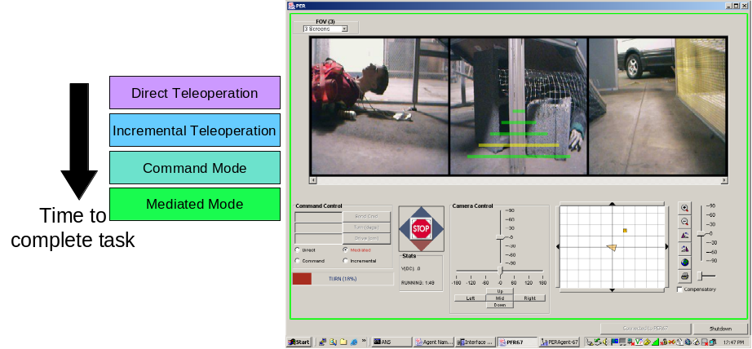
Fig 3. The user interface has four control modes. A sample screen shot of the user interface using the mediated control mode to control the robot. The operator could, for example, simply click on one of the two victims in the robot’s field of view to direct the robot explore that victim.
This interface has been demonstrated to allow a single operator to control multiple robots. It is particularly important however that the robots have a sufficient level of autonomy for this control paradigm to work. All robots have the basic atomic commands goTo and turnTo. In addition, we are working on adding a climbStairs routine for the Tarantula robot and incorporating the mapping capabilities of the Pioneer.
- Map generation/printing
We are augmenting our robot team this year with a Pioneer P3-AT with ActivMedia’s Laser Mapping and Navigation System (ARNL) with the gyroscope correction system. We plan on using their MAPPER software to compile the data from the laser range finder into a map. The map can then be edited and annotated by the operator. ARNL localizes the robot using Monte Carlo and Markov techniques. ARNL also provides methods for navigating the robot using a modified value iterated search approach.
- Sensors for Navigation and Localization
Our robots use vision, range sensors, odometry data, and acceleration information for navigation and localization, though to varying degrees. Each robot has a USB web cam mounted on a pan tilt head. The resolution of the cameras and processing power constraints of the onboard computers make it unfeasible to run sophisticated vision algorithms to aid autonomous navigation but the video is transmitted to the human operator who can use this data to guide the robot.
The Pioneer robot has a laser range finder for mapping and localization. It also has a gyroscope correction system to adjust odometry due to variations in terrain that characterize disaster situations. The TurboPERs have only one range sensor, mounted on the pan tilt head. The Tarantula may have a similar range sensor to aid in obstacle avoidance and stair climbing. The Tarantula and TurboPER robots rely heavily on odometry data for localization. The TurboPER has a high gear ratio that allow the wheels to turn at a near constant velocity independent of load. The motors are controlled through the Cerebellum board, a fast, low cost, PIC based microcontroller. Open loop position estimation works well experimentally and is very simple and inexpensive.
- Sensors for Victim Identification
In order to detect as many different properties of victims as possible, we are using four different complementary sensors: USB cameras, microphone, pyroelectric sensor and infrared camera. The TurboPER has a relatively limited sensor suite for victim identification of only the Creative WebCam Pro USB camera and pyroelectric sensor. It can detect motion and identify victims with the help of the human operator as well as confirm the presence of heat on a victim.
Due to payload constraints, the Tarantula will only be able to carry a lightweight camera. We may experiment with the addition of a pyroelectric sensor and IR range sensor as well.
The Pioneer carries an extensive sensor suite designed and tested for victim identification including the Watchport Pro webcam which operates well in low light, a microphone, and a Murata pyroelectric sensor with a Fresnel lens. This robot can survey its environment for motion, heat, and sound, fuse the data together, and suggest places for further exploration to the human operator who can efficiently examine the scene for shapes and colors that indicate human presence.
Additionally, we have a Raytheon infrared camera which may be mounted on the Pioneer or one of the TurboPERs. This camera is effective at detecting heat, analyzing the shape of the heat source, and detecting motion of the heat source. For sample results refer to figures 6 and 7 and to Burion’s work [2].
The algorithm for motion detection requires the simple subtraction of two successive images taken while the robot was at rest. With assumptions on the distance to the moving object, the number of disparate pixels has empirically been shown to correspond to the probability that the motion detected was actually caused by a victim (see Appendix) [2]. Although more advanced motion detection algorithms are certainly available, this algorithm can be performed in real time on the onboard computer and the results are relatively accurate as shown in figure 3.

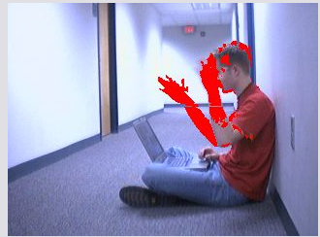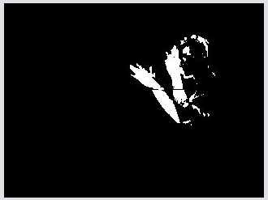
At 3m: changing pixels: N = 3.2%
Mean value m = 72
Fig. 4. Results of motion detection algorithm. Pixels that changed between the images are on the right with overlay onto the original image on the left.
We also employ a Murata IMD-B101-01 pyroelectric sensor, designed to detect moving heat sources with wavelengths in the range of 5-14 μm (heat produced by humans has a wavelength of approximately 7 μm) [2]. A Fresnel lens extends the range of this sensor to 5 meters. Since the pyroelectric sensor only works when the heat source is moving, the sensor is mounted on the pan tilt head and scans the environment when the head moves.
Our sound detection assumes that the calls for help of trapped victims are louder than ambient noise. Initial calibration of the system suppresses the ambient noise. Sound detection is then performed in the time domain. Our algorithm detects sustained high amplitude sound and returns the duration of the sound and the mean amplitude. This information can be used as input to an empirically determined function of probability that the noise detected was generated by a victim (see Appendix) [2]. This algorithm for voice detection lacks the ability to distinguish between human and non-human sources of noise but can be run in real time onboard the robot’s computer. We plan to add the capability to record interesting sound as a wave file and transmit it back to the human operator for analysis. Sample results of the voice detection algorithm are shown in figure 4.
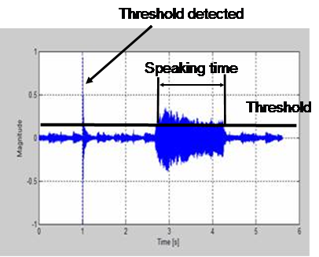
Fig. 5. Sample voice detection results illustrating that short noises that are unlikely to be human voices are filtered
Our final and most powerful sensor for human detection is the Raytheon Infrared camera 2000b. This camera provides images of the environmental heat in gray scale where white indicates hot objects and black indicates cold objects. The spectral range is 7- 14 μm. We use the analog output of the infrared camera and transmit the image via an analog transmitter to a frame grabber on an external computer. The image is analyzed to determine the location of the largest brightest section of the image, which is returned as the most likely location of the victim. The image is currently also analyzed for motion as a moving hot spot is probably a victim in a real disaster environment. This analysis, which uses the tLib library [3] is computationally expensive and is performed on an external computer. For the competition, we plan to remove this step. A sample image from the infrared camera is shown in figure 5 with the head of the victim correctly identified.
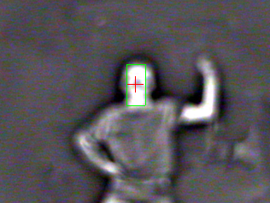
Fig. 6. A sample image from the infrared camera with the victim’s head correctly identified in green
The results from each sensor are fused together by weighting each probability with confidence values (Figure 7). These confidence values can either be empirically determined, set at calibration time, or set by the operator. For more information on the sensor fusion, refer to [2] and Appendix.

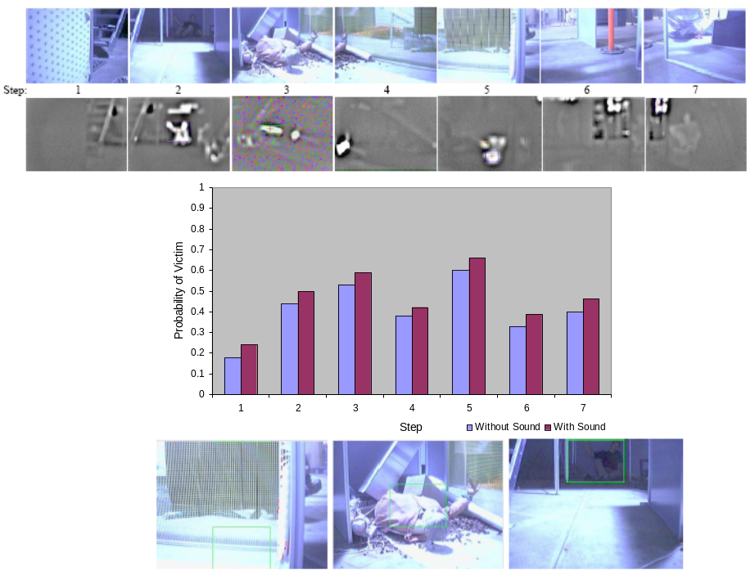
Fig. 7. The robot surveys its environment (top), analyzes motion, sound, and heat, and creates a probability of a victim at each location (middle). The top three results are submitted to the operator for further analysis (bottom). In this case, the victims found included a person standing behind a curtain, a mannequin with an electric blanket, and a person hidden in shadow (steps 5, 3, and 2 respectively).
- Robot Locomotion
In our efforts to explore coordination of a team of heterogeneous robots and agents, we have developed a diverse team of robots consisting of a Tarantula robot, a Pioneer P3-AT, and two TurboPERs. The TurboPERs are small, 6-wheeled robots with rocker bogie suspension that are easily controlled by an operator. They provide relatively inexpensive and robust “robotpower” to search the space more quickly and can provide an additional point of view, which can be useful in navigating other robots through the environment. The P3AT is a rugged all terrain robot primarily used to map the environment. It can also carry larger payloads than the other robots. It’s larger size enables it to travel more quickly than the other robots, but also limits its range. The Tarantula is a treaded robot with actuated arms that enable it to negotiate stairs and other extreme terrain inaccessible to the wheeled robots.

8.1 Tarantula
The Tarantula Ascendor EKO-05 is an R/C toy available for under $100. It is equipped with large actuated arms covered in rubber treads (Figure 8) that enable it to climb stairs and traverse extreme terrain. We are in the process of outfitting it to perform simple atomic commands goTo and turnTo as well as climbStairs (for a calibrated set of stairs). Although this robot has excellent mobility, the lack of sensors makes it unusable. We are adding a security camera that can wireless transmit images to a base station on one of the other robots.

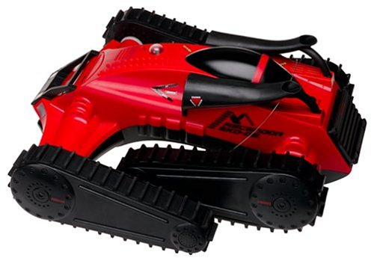
Fig. 8. Tarantula Ascendor EKO-05 has arms with rubber treads. We modify the shell to add electronics and a security camera.

8.2 Pioneer P3-AT
The P3-AT (Figure 9) has a 4 wheel drive holonomic skid-steer platform. It measures approximately .5 meters on a side and is .25 meters tall. The body is made from 1.6mm CNC fabricated painted aluminum. The wheels are made from pneumatic nylon with chevron treads. The four drive motors use 66:1 gear ratios. The robot can turn in place, climb a 45% grade and overcome obstacles with heights up to 9cm. It has a maximum speed of 70 cm/s and can carry an impressive payload. It can run over an hour on a single battery. For more information on this commercially available robot, please refer to the manufacturer’s website [?].

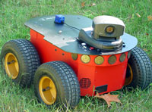
Fig. 9. Pioneer P3-AT with webcam. The pioneer in the competition will have an additional laser range finder mounted and no sonar sensors.

8.3 TurboPERs
The Personal Exploration Rover or PER was developed at Carnegie Mellon University as part of a larger project to develop low-cost robots for education, science museums, and homes. Forty PER robots were built and deployed at science centers around the country for educational use in “Mars Yards”, environments designed to imitate the environment on Mars.
The PER uses a rocker-bogie mobility system and has a differential axle that serves as the attachment point for the left and right wheel structures and the main rover body. The differential ensures that the main body angle always averages the left and right wheel rocker angles.
The PER has independent front and rear wheel steering, powered by four motors. We increased the speed of these motors in the TurboPERs to be over twice as fast as the original PERs. Each motor uses 16 volts and is small enough to fit inside the robot’s custom wheels. Each wheel is connected to a servo allowing the wheels to be individually steered. This allows the robot to move sideways, although current control methods do not fully utilize the power of this drive system. The wheels were custom-manufactured for the PER, designed to mate with the Hsiang drive motors. The middle wheels are omnidirectional, enabling the rover to move sideways. [6,7]
The robot measures .4 meters tall, .2 meters wide, and .3 meters long. It is easily transported by a single person at 4.5 kilograms (10 pounds). After observing that the PERs handled rubble and obstacles well but were too slow to explore much of the arena during the time limits, we increased their speed. We have 2 of these TurboPERs on our team.

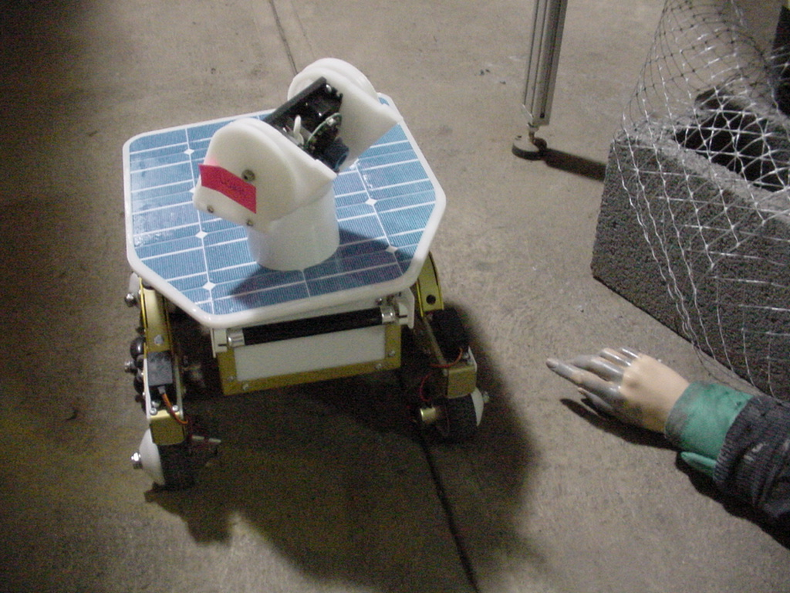
Fig. 10. TurboPER robot explores the arena
- Team Training for Operation (Human Factors)
We intend to use our simulations for initial operator training. Desirable operator skills are likely to involve the perceptual problems of identifying victims and other features from low resolution video, shifting attention between robots, shifting between automated navigation and teleoperation, and maintaining situational awareness. We are attempting to make these tasks easier by limiting the number of independent displays and providing as much information as possible through HUD-like overlays on the video display. Further operator training will occur with the real robots in the orange level disaster arena developed by the National Institute of Standards and Technology (NIST).
USARSim [11] is the simulation we built to help people test and evaluate the design and performance of remotely controlled robots in urban search and rescue environments. The simulator uses the Unreal engine on which Unreal Tournament and other video games are based to provide a high fidelity interactive environment that includes 3D environment simulation of the yellow, orange, and red NIST arenas that include textures, glass, and mirrors, a rigid-body physics engine to build robot models to simulate mechanical robots, and accurate noisy robot sensors.
- Team Training for Operation (Human Factors)
Practical application to a real disaster site requires several basic issues in robotics to be fully addressed. The robot must have the power autonomy to function for a long enough duration to improve the state of information and allow slow and deliberate exploration; the robot must be reproducible and low-cost enough to warrant construction of a number of units, for both redundancy in the face of failure and so that the rescue team can benefit from the advantage of greatly increased numbers of eyes and ears in the disaster site; the robot must truly have the locomotive means to travel robustly through at least a subset of true disasters, where its particular array of sensors and/or effectors is of value; finally the robot must provide out-of-the-box functionality that is truly desirable to the current players at the scene of a disaster.
- System Cost

TOTAL SYSTEM COST (per TurboPER): approx. $4000
See website: www.cs.cmu.edu/~personalrover/PER/

KEY PART NAME: Sharp GP2Y0A02YK IR Sensor
PART NUMBER: R144-GP2Y0A02YK
MANUFACTURER: Sharp
COST: $15
WEBSITE: www.acroname.com
DESCRIPTION/TIPS:
Sensor mounted to pan tilt head of PER for obstacle avoidance.

KEY PART NAME: 7 in 1000/PK CABLE TIES 40lbs
PART NUMBER: CT07-1000
MANUFACTURER: CableOrganizer
COST: $54.99
WEBSITE: www.cableorganizer.com
DESCRIPTION/TIPS:
Cable ties to secure various wires on PER—obviously 1000 ties are not needed for each robot.

KEY PART NAME: 0.25x20 FT WIRE LOOM
PART NUMBER: WL025-20
MANUFACTURER: CableOrganizer
COST: $12.50
WEBSITE: www.cableorganizer.com
DESCRIPTION/TIPS:
Wire Loom for Legs.

KEY PART NAME: .5x20 FT WIRE LOOM
PART NUMBER: WL050-20
MANUFACTURER: CableOrganizer
COST: $13.50
WEBSITE: www.cableorganizer.com
DESCRIPTION/TIPS:
Wire Loom for Neck.

KEY PART NAME: CONN HOUS 3POS .100 W/RAMP/RIB
PART NUMBER: WM2001-ND
MANUFACTURER: Molex/Waldom Electronics Corp.
COST: $0.29 each
WEBSITE: digikey.com
DESCRIPTION/TIPS:
One of many connectors used on PER. Manufacturer part number 22-01-3037.

KEY PART NAME: CONN 2.5MM FEMALE PLUG 5.5MM OUT
PART NUMBER: CP-004B-ND
MANUFACTURER: CUI Inc.
COST: $0.65 each
WEBSITE: digikey.com
DESCRIPTION/TIPS:
Stayton power plug. CUI Inc. part number PP-002B.

KEY PART NAME: SWITCH ROCK SPST ILLUM W/GRN LED
PART NUMBER: EG1859-ND
MANUFACTURER: E-Switch
COST: $2.96 each
WEBSITE: digikey.com
DESCRIPTION/TIPS:
Power switch and LED. Other names EG1859, M301215, R1966AKKESM.

KEY PART NAME: CONNECTOR,IDC D-SUB,MALE,9PIN
PART NUMBER: 109225
MANUFACTURER: Jameco ValuePro
COST: $1.35 each
WEBSITE: jameco.com
DESCRIPTION/TIPS:
Male serial connector. Manufacturer number 1007-9P/M

KEY PART NAME: CONNECTOR,IDC D-SUB,FEM,9PIN
PART NUMBER: 109217
MANUFACTURER: Jameco ValuePro
COST: $2.49 each
WEBSITE: jameco.com
DESCRIPTION/TIPS:
Female serial connector. Manufacturer number 1007-9S/M

KEY PART NAME: CABLE,28AWG,FLAT GRAY,10COND
PART NUMBER: 135538
MANUFACTURER: Jameco ValuePro
COST: $1.49 each
WEBSITE: jameco.com
DESCRIPTION/TIPS:
Ribbon cable

KEY PART NAME: Various heat shrink tubing
PART NUMBER:
MANUFACTURER: Jameco ValuePro
COST: about $1.00
WEBSITE: jameco.com
DESCRIPTION/TIPS:
Used for various wire connections

KEY PART NAME: 3M Scotch VHB Foam Tape-Adhesive Both Sides
PART NUMBER: 75935A657
MANUFACTURER: 3M
COST: $73.19/roll
WEBSITE: mcmaster.com
DESCRIPTION/TIPS:
Each roll is 36 yards long. If you’re not mass producing PERs like we did, it might be best to get tape elsewhere.

KEY PART NAME: Loctite 222 Threadlocker Adhesiv,10 ml,Purple
PART NUMBER: 91458A11
MANUFACTURER: Loctite
COST: $9.73
WEBSITE: mcmaster.com
DESCRIPTION/TIPS:
Threadlock for Screws 10405

KEY PART NAME: Loctite Prism Super Glue Surface-Insensitive, #4471
PART NUMBER: 74765A34
MANUFACTURER: Loctite
COST: $17.79
WEBSITE: mcmaster.com
DESCRIPTION/TIPS:
Superglue for wheels

KEY PART NAME: Loctite Primer Prism Primer #770, 1.75 oz Bottle
PART NUMBER: 66205A24
MANUFACTURER: Loctite
COST: $12.60
WEBSITE: mcmaster.com
DESCRIPTION/TIPS:
Primer for wheels

KEY PART NAME: 10in Futaba J Servo Extension
PART NUMBER: 10405
MANUFACTURER: Futaba
COST: $2.50 each
WEBSITE: rc-dymond.com
DESCRIPTION/TIPS:
Servo extensions

KEY PART NAME: DuraTrax Old Kyosho Battery Connector & Wire
PART NUMBER: DTXC2280
MANUFACTURER: DuraTrax
COST: $1.49
WEBSITE: towerhobbies.com
DESCRIPTION/TIPS:
Battery power connector

KEY PART NAME: 7.2v NiMH 3000mah battery pack
PART NUMBER: 10486
MANUFACTURER: onlybatterypacks.com
COST: $28.00 x 4
WEBSITE: onlybatterypacks.com
DESCRIPTION/TIPS:
Battery pack (4 per rover)

KEY PART NAME: Creative WebCam Pro
PART NUMBER:
MANUFACTURER: Creative
COST:
WEBSITE:
DESCRIPTION/TIPS:
No longer in production.

KEY PART NAME: Cerebellum
PART NUMBER:
MANUFACTURER: Botrics
COST:
WEBSITE: botrics.com
DESCRIPTION/TIPS:
v1.03 Similar to acroname brainstem

KEY PART NAME: Power Board
PART NUMBER:
MANUFACTURER: Botrics
COST:
WEBSITE: botrics.com
DESCRIPTION/TIPS:
v0.2

KEY PART NAME: HS-225MGj
PART NUMBER:
MANUFACTURER: Hitec
COST: $34.99
WEBSITE: hobbiesr.com
DESCRIPTION/TIPS:
May not be available anymore… Hitec 225MG futaba J type servo for tilt in pan-tilt head.

KEY PART NAME: Stayton board
PART NUMBER:
MANUFACTURER: Intel
COST:
WEBSITE:
DESCRIPTION/TIPS:
Not available for sale but newer models of PER use Stargate board. See PER documentation online and distributor website www.xbow.com.

KEY PART NAME: GWServo S11 HP/2BB MG
PART NUMBER:
MANUFACTURER:
COST:
WEBSITE:
DESCRIPTION/TIPS:
Steering servos—No longer available. Replacement parts are available. Contact us for more info.

KEY PART NAME: GWServo 125 1T/2BB
PART NUMBER:
MANUFACTURER:
COST:
WEBSITE:
DESCRIPTION/TIPS:
Pan servo in pan tilt head

KEY PART NAME: MOTOR,GEAR,42rpm@12vdc SHFT:.16Dx.6L,SOLDER TAB
PART NUMBER: 159417
MANUFACTURER: Jameco Reliapro
COST: $23.95 x 4
WEBSITE: jameco.com
DESCRIPTION/TIPS:
Drive motors (different than part number 170641 in original PER which have 10rpm)

KEY PART NAME: Chassis
PART NUMBER:
MANUFACTURER:
COST:
WEBSITE:
DESCRIPTION/TIPS:
Custom made—refer to PER website for schematic, software, and firmware

TOTAL SYSTEM COST (per P3-AT): approx. $15000

KEY PART NAME: Pioneer P3-AT base
PART NUMBER: P3T0001
MANUFACTURER: ActivMedia
COST: $5,995
WEBSITE: activmedia.com
DESCRIPTION/TIPS:
The PIONEER 3-AT is a highly versatile all-terrain robotic platform, software compatible with all ActivMedia robots. It has Ethernet based communications, can travel at up to .7m/s and carry a payload of up to 30kg. It uses 100 tick encoders, 66:1 gear ratios on its four drive motors, and has skid steering. The platform is holonomic and can rotate in place or can turn to form a circle of radius 40cm.

KEY PART NAME: Laser Mapping and Navigation AT
PART NUMBER: ACA0023
MANUFACTURER: ActivMedia
COST: $7,495
WEBSITE: activmedia.com
DESCRIPTION/TIPS:
The laser range finder interfaces with ActivMedia Robotics Navigation Layer to make build maps and navigate.

KEY PART NAME: Gyro Correction System
PART NUMBER: ACA0090
MANUFACTURER: ActivMedia
COST: $280
WEBSITE: activmedia.com
DESCRIPTION/TIPS:
The gyroscopic correction system allows inertial corrections which are particularly important with the skid steering system used by the P3AT. It is also important to correct for dead reckoning and slippage in uneven terrains such as the search and rescue environment.

KEY PART NAME: P3 AT Rear Sonar
PART NUMBER: ACAT032
MANUFACTURER: ActivMedia
COST: $470
WEBSITE: activmedia.com
DESCRIPTION/TIPS:
The laser range finder is suitable for obstacle avoidance in the front. We added a rear sonar ring to avoid backing into obstacles.

KEY PART NAME: Controlling laptop
PART NUMBER:
MANUFACTURER: Varies
COST: Varies
WEBSITE:
DESCRIPTION/TIPS:
The P3AT can be controlled by any windows or linux laptop. In addition, the laptop controls additional sensor that may be mounted to this robot such as the IR camera, additional low light cameras, microphones, etc.

TOTAL SYSTEM COST (per Tarantula): approx. $1000

KEY PART NAME: Radio Control Tarantula Vehicle: Ascendor EKO-05 (27MHz)
PART NUMBER:
MANUFACTURER: MGA Entertainment
COST: $99.99
WEBSITE: amazon.com
DESCRIPTION/TIPS:
This radio control base has great mobility for a low price. We’re still in the process of retrofitting for the competition and so don’t know yet which parts we will use. We anticipate a wireless camera such as the DLINK DSC-5300W, some controllers like the cerebellum and encoders, and a transmitter/receiver.

References
1. Berna-Koes, M., Nourbakhsh, I., Sycara, K.: Communication Efficiency in Multi-Agent Systems. Proceedings of IEEE 2004 International Conference on Robotics and Automation. (2004)
2. Burion, S.: Human Detection for Robotic Urban Search and Rescue. Available Online: http://www-2.cs.cmu.edu/afs/cs/project/retsina-31/www/Report/Final%20Report.pdf (2004)
3. Grange, S., Fong, T., Baur, C.: TLIB: a real-time computer vision library for HCI. VRAI-Group, EPFL, Lausanne (2003)
4. 5. National Institute of Standards and Technology (NIST): Performance Metrics and Test Arenas for Autonomous Mobile Robots. [Online] Available: http://www.isd.mel.nist.gov/projects/USAR. (2004)
6. National Science Center: Mars Rover Project Educational Guide. [Online] Available: http://www.nationalsciencecenter.org/FortDiscovery/Events/documents/MarsEducationGuide.pdf. (2004)
7. Nourbakhsh, I.: The Personal Exploration Rover. [Online] Available: http://www-2.cs.cmu.edu/~personalrover/PER/ (2004)
8. Sycara, K., Paolucci, M., van Velsen, M., Giampapa, J.: The RETSINA MAS Infrastructure. Special Joint Sigue of Autonomous Agents and MAS. Vol. 7, No. 1 and 2, (July 2003)
9. Sycara, K., Widoff, S., Klusch, M., Lu, J.: LARKS: Dynamic Matchmaking Among Heterogeneous Software Agents in Cyberspace. Autonomous Agents and Multi-Agent Systems. Vol. 5, 173-203 (2002)
10.Wang, J., Lewis, M., Gennari, J.: A Game Engine Based simulation of the NIST USAR Arenas. Proceedings of the 2003 Winter Simulation Conference (2003)
APPENDIX
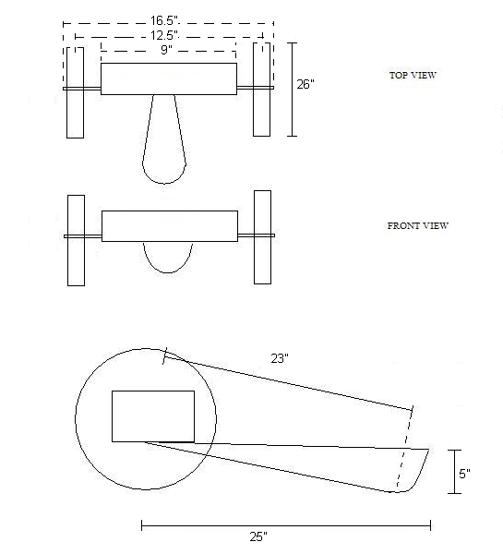
Drawing of Corky robot
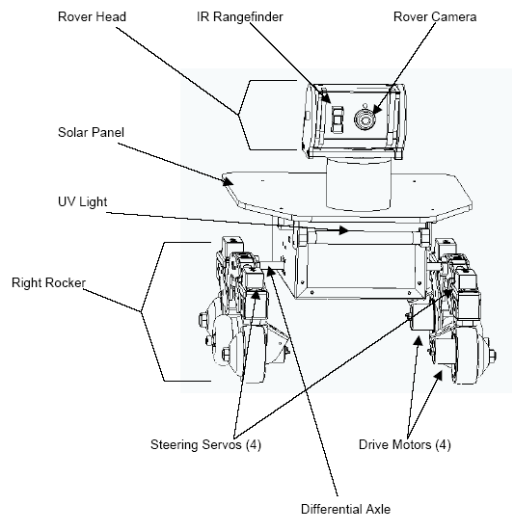
Drawing of PER robot
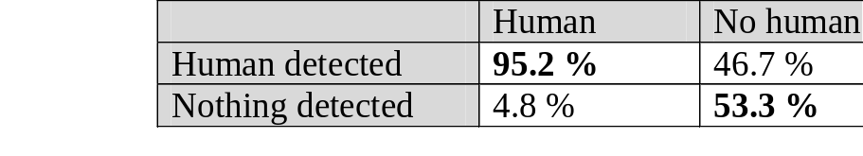
Accuracy of Pyroelectric Sensor

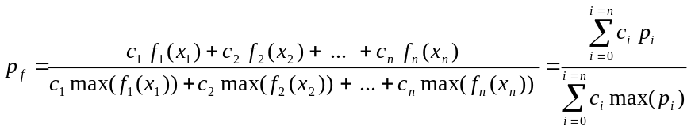
Formula for sensor fusion with:
c = confidence value of each sensor,
f(x) = function which give a probability to have a human for each sensor
pf = final probability
For the complete description of sensor models used on robot, please refer to [2]

